Experiment No. – 3
Date of Performance: | 29/7/2025
Date of Submission: | 5/8/2025
Program Execution/  formation/  correction/  ethical practices  (06) | Timely  Submission  (01) | Viva  (03) | Experiment  Total (10) | Sign with Date

Experiment No. 3
Matplotlib and Seaborn in Python.

1.1 Aim: Implementation of Matplotlib and Seaborn in Python.

1.2 Course Outcome: Understand the concept of Fuzzy Logic and application.

1.3 Learning Objectives: Analyze the data using different statistical techniques and visualize the outcome using different types of plots.

1.4 Requirement:Python (Google Colab)

1.5 Related Theory:

What is Data Visualization?
Data visualization is the graphical representation of information and data. By using visual elements like charts, graphs, and maps, data visualization tools provide an accessible way to see and understand trends, outliers, and patterns in data.In the world of Big Data, data visualization tools and technologies are essential to analyze massive amounts of information and make data-driven decisions.

Common general types of data visualization:

● Charts
● Tables
● Graphs
● Maps
● Infographics
● Dashboards

What is Exploratory Data Analysis?

Exploratory Data Analysis refers to the critical process of performing initial investigations on data so as to discover patterns, to spot anomalies, to test hypotheses and to check assumptions with the help of summary statistics and graphical representations.

What is Matplotlib?

Matplotlib is the most utilized and the most well-known python plotting library. Notice cautiously, and you will see a striking similarity among MatrixLaboratory or MATLAB’s and Matplotlib plotting curves. The Matplotlib plots the curves are very similar to Matrix Laboratory or MATLAB. The solitary difference is Matrix Laboratory, or MATLAB requires a license and is very costly. Each part of the figure can be controlled utilizing this Matplotlib library. Discussing its sole developer and founder, it is John Hunter and conveys it under a BSD license.This open-source plotting library contains an Application Programming
Interface that causes you to insert plots in applications. One of the benefits Matplotlib has is the way that its interface is very straightforward. Utilizing Matplotlib we can pie, scatter plot, plot lines,and considerably more. It contains an Object-Oriented Application Programming Interface that encourages us to implant the library in our manners.
What is Seaborn?

Seaborn library is for making Python statistical graphics. It expands on top of matplotlib and coordinates the panda’s data structures closely.Seaborn permits you to understand and explore your information rapidly. It works by catching whole data arrays or frames containing all your information and playing out every one of the inside functions vital for statistical aggregation and semantic mapping to change over information into enlightening plots.A seaborn scatter plot is an outline that showcases focus dependent on two components of the dataset.
Histogram :

Histogram plots are used to better understand how frequently or infrequently certain values occur in a given set of data. To understand the method behind constructing a histogram, imagine a set of values that are spaced out along a number line. To construct a histogram, a section of the number line is divided into equal chunks, called bins. In the image below, the data is divided into five bins (note that for a histogram, the bins all must be the same width).Next, count up how many data points sit inside each bin, and draw bars, one foreach bin, whose heights correspond to the number of data points. This process is illustrated below.Label the data (in the example below each data point is an SAT score), draw in a y-axis which counts the number of data points in each bin, and finally labels your bins.
1.6 Procedure:
We will import our dataset with the help of pandas.Find out the last five rows of our datasets.We check for the data types, and also drop the irrelevant columns which are not required to train the model.
This helps to plot the bar graph.This is use to plot histogram.First we display the data and then we plot the graph

1.7 Program and Output:

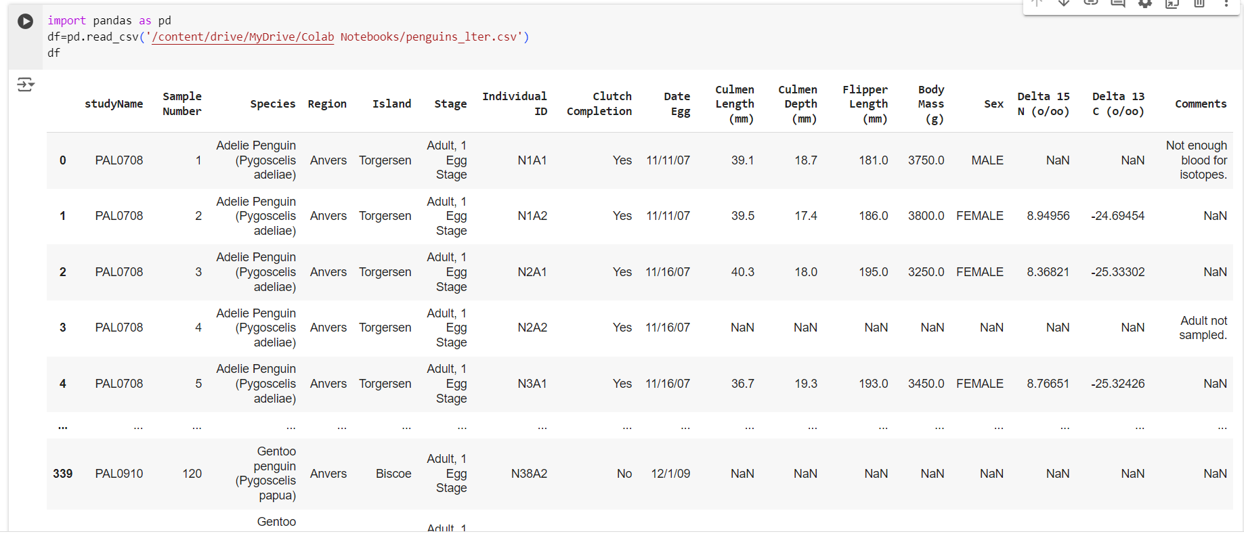

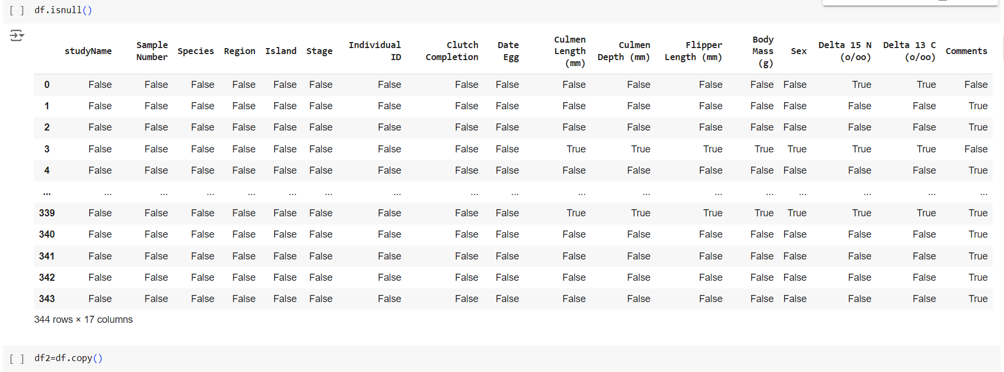

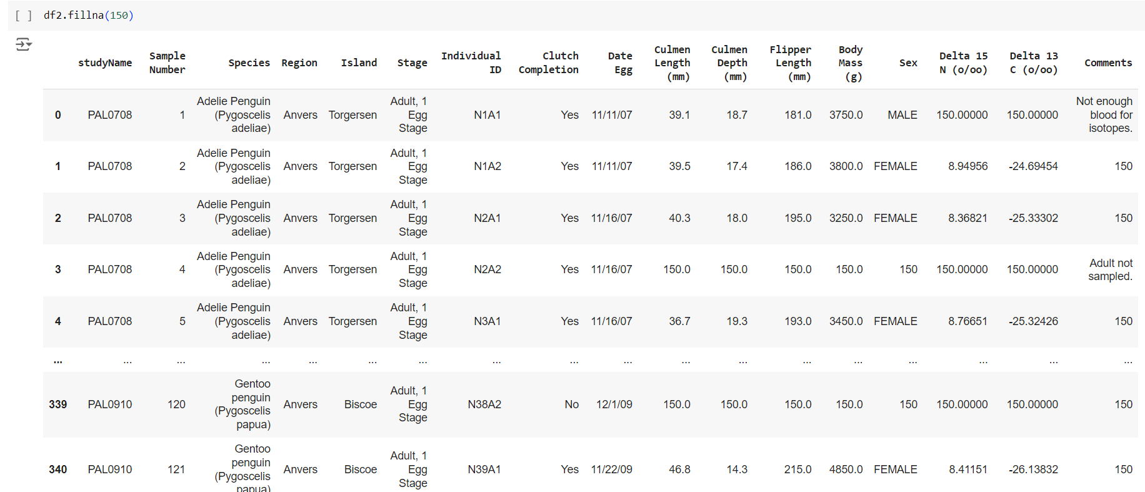

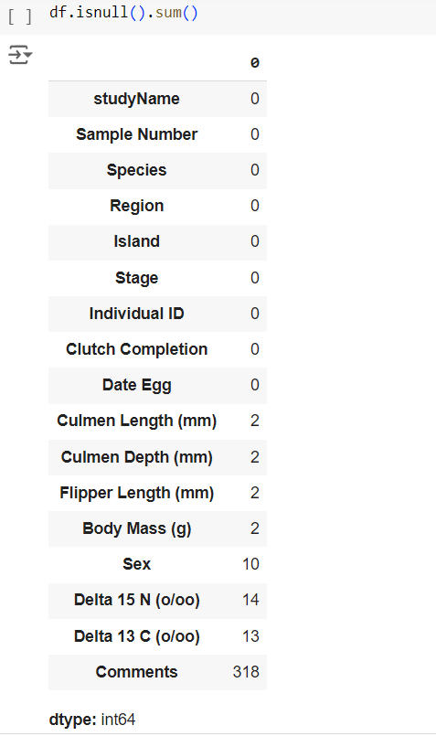

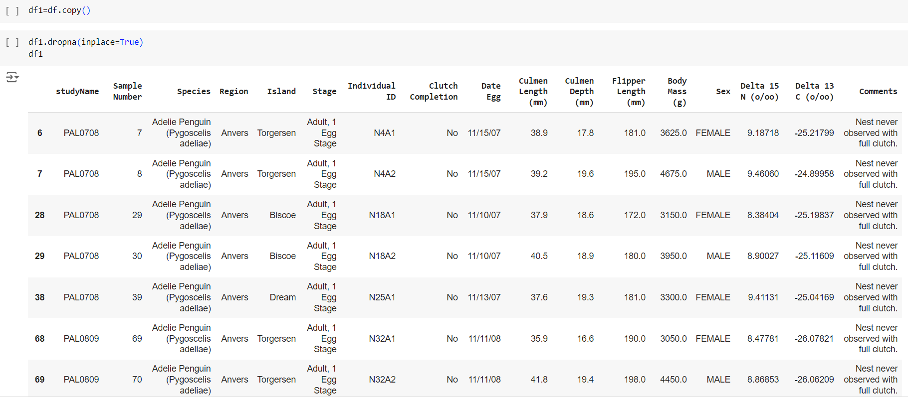

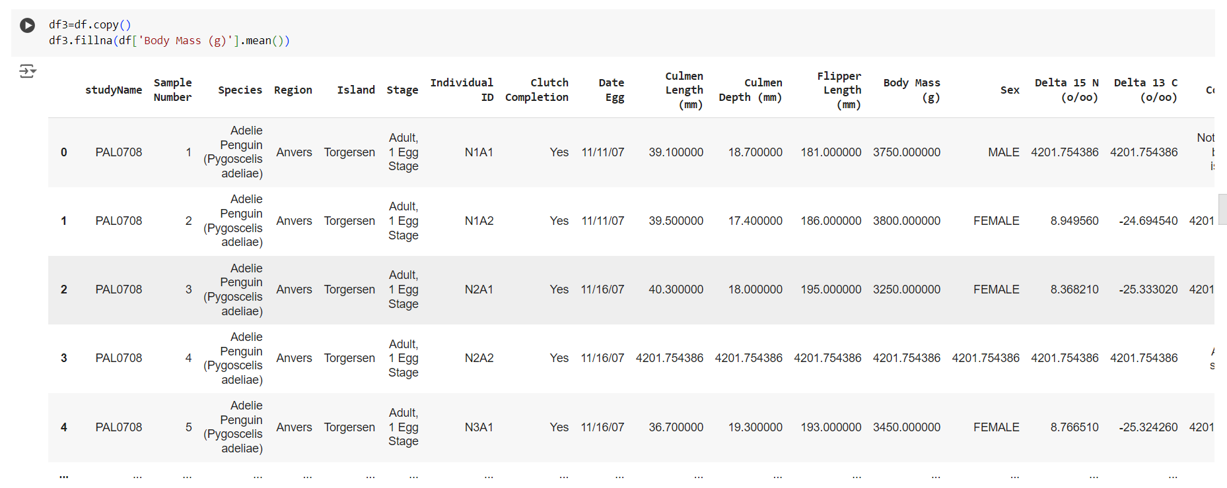

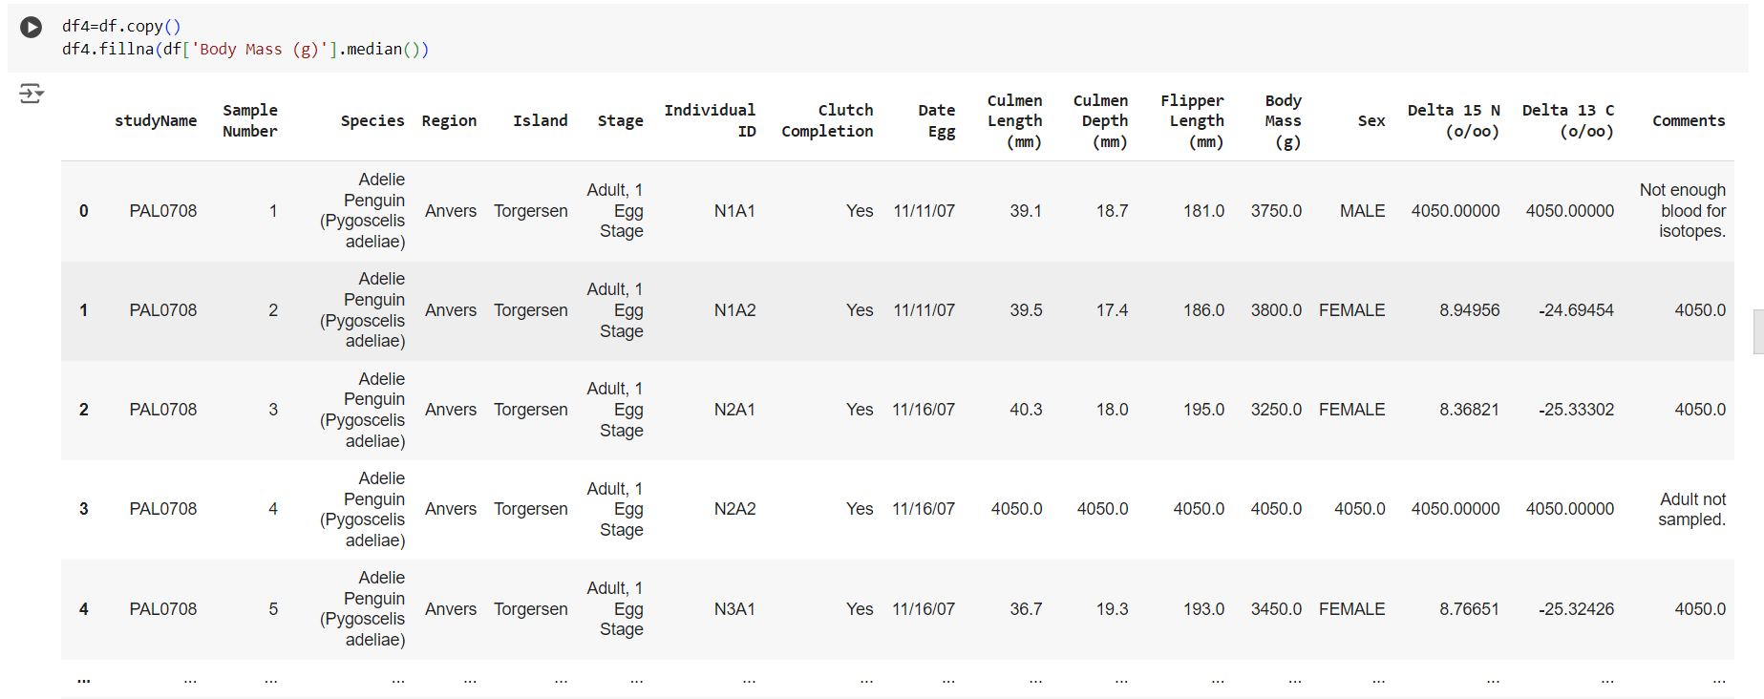

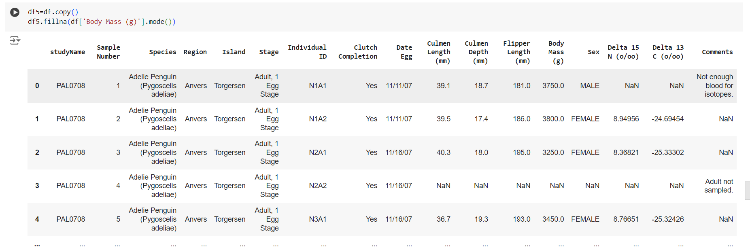

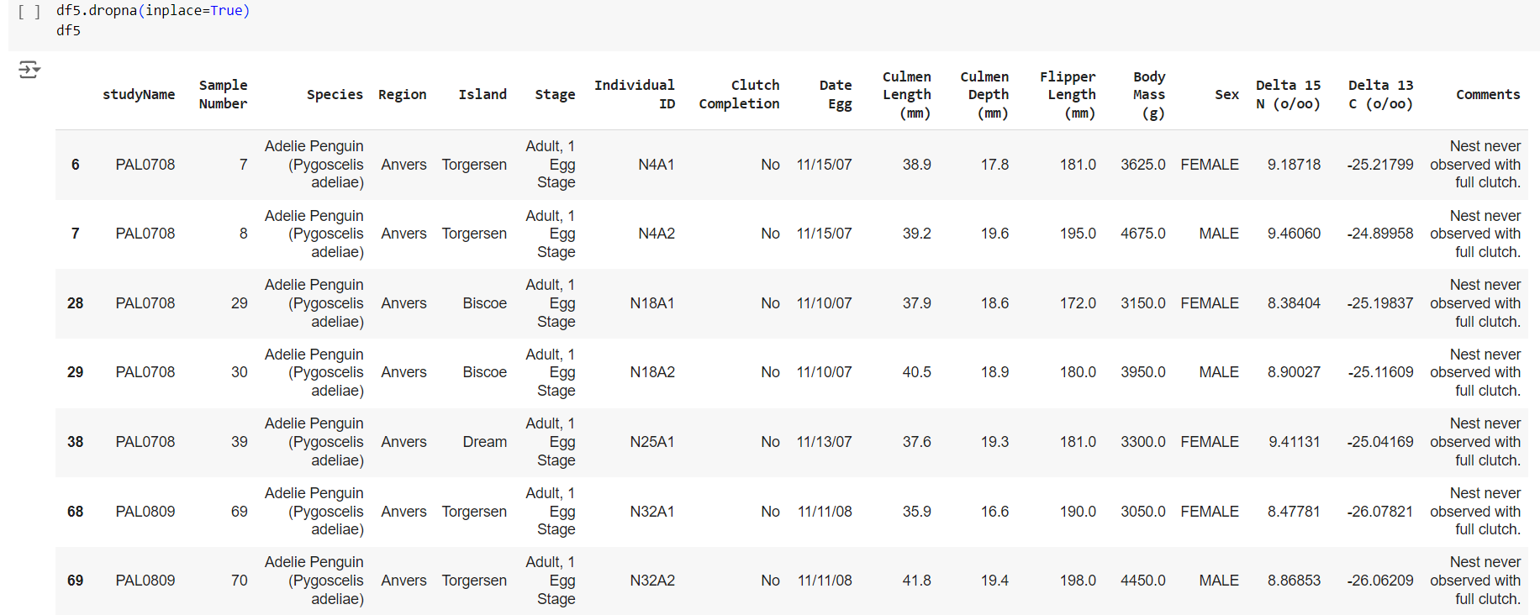

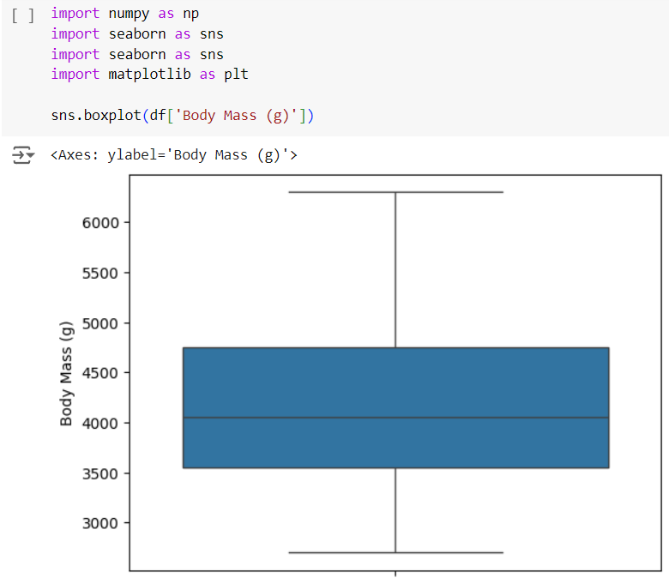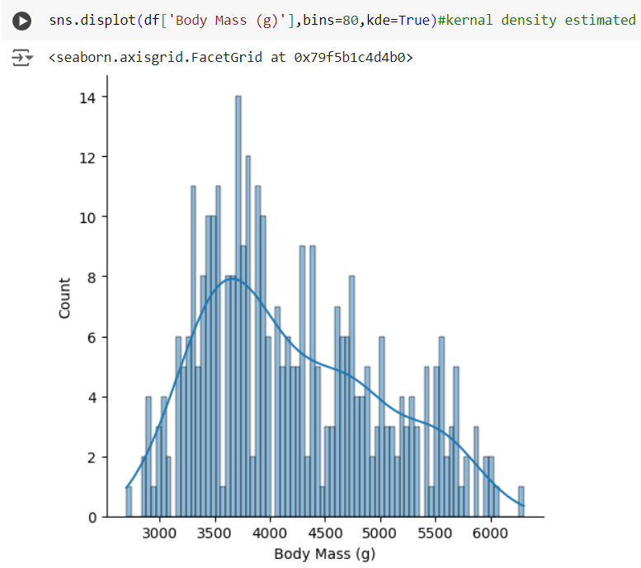

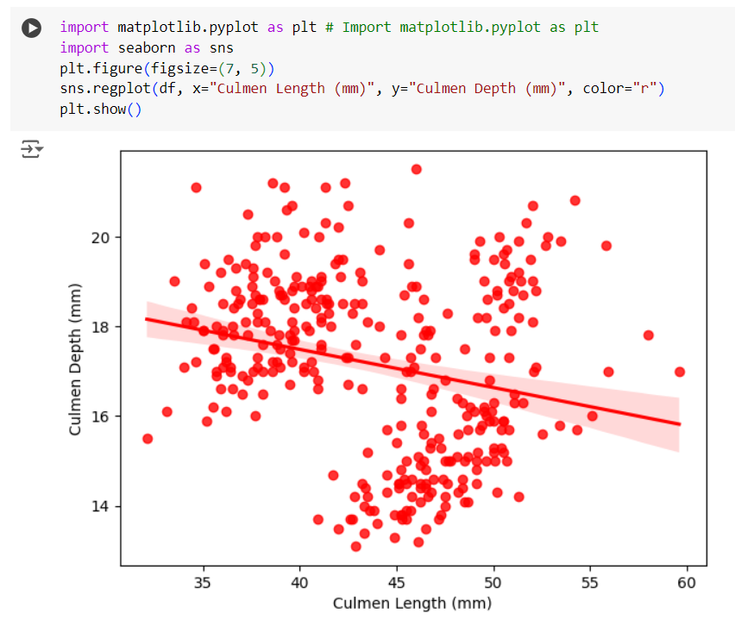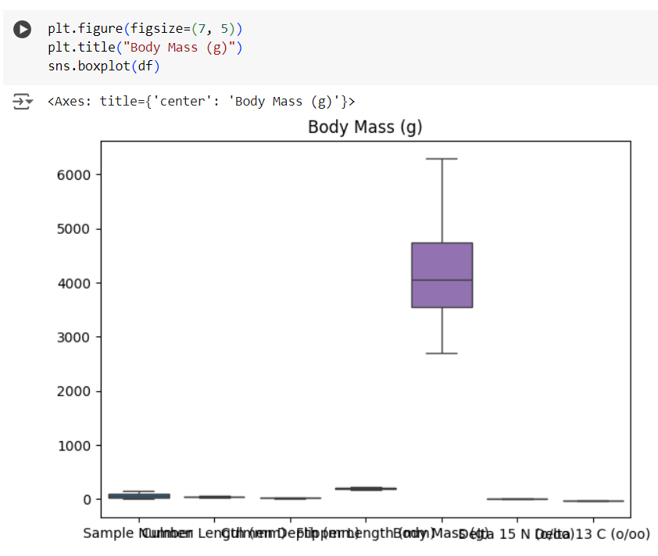

1.8 Conclusion:
In this experiment, we explored how to use Matplotlib and Seaborn for data visualization in Python. While Matplotlib provides a powerful framework for creating basic plots with extensive customization, Seaborn offers an easier and more aesthetically pleasing way to generate statistical graphics. Both libraries complement each other and are widely used for creating insightful visualizations in data analysis and cognitive applications. By mastering these tools, we can effectively communicate data insights and patterns.

1.9 Questions:
1.What is data visualization ?
Ans: Data visualization is the graphical representation of information and data. It involves using visual elements like charts, graphs, maps, and infographics to present data in a way that makes it easier to understand patterns, trends, and insights.
The main goal of data visualization is to help people quickly and effectively interpret large amounts of data and gain actionable insights. By transforming complex datasets into visual formats, it becomes easier to spot relationships, outliers, and trends that might not be obvious from raw data alone. This approach is widely used in fields like business, science, and engineering to support decision-making and data analysis.

2. Explain scatter plot with diagram.
Ans: A scatter plot is a graphical representation of two variables, using Cartesian coordinates to display data points for each observation.
Key Features:
Axes: The x-axis represents one variable, while the y-axis represents another.
Data Points: Each point's position is determined by its values for the two variables, indicating their relationship.
Trends: Patterns in the points can show correlations, such as positive (both variables increase), negative (one increases while the other decreases), or no correlation (random scatter).
Outliers: It helps identify outliers—points that differ significantly from others.
